LEGISLATIVE NEWSLETTER WEEK 7

Senators Crapo and Risch Address the Idaho Legislature
On Wednesday, Idaho’s Republican Senators Mike Crapo and Jim Risch addressed each chamber of the Idaho legislature. Their message to all of Idaho's 105 legislators was clear: Congress could learn something about good governance from the Idaho Legislature. Senator Crapo was highly complimentary of Idaho’s low unemployment and status as the least regulated state in the country but painted a dismal portrait of the American economy, pointing to rising inflation and Democratic party priorities related to increasing both taxes and spending. Senator Risch noted that he and Senator Crapo work closely together on critical votes to ensure that Idaho’s voice and interests are well-represented in Washington D.C. Both Senators thanked legislators for their hard work to ensure prosperity for Idaho families and to uphold Idaho values.

Current and Former Senators Pay Tribute to Colleagues at the Annual Senate Memorial Service
On Monday, the Idaho Senate paid tribute to former colleagues. A long-standing tradition, Senators memorialize past members who died in the past two years. This year’s service was a bit longer than normal, as the tradition was suspended last year due to COVID. Those on the Senate’s memorial list included Sens. Ray Rigby, Betty Benson, William L. “Wild Bill” Crookham, Shirley McKague, Terry Lee Sverdsten, Cecil Ingram, Lin Whitworth, Dick Compton, John Mix II, and Don Burtenshaw. Several former Senators, including now-Governor Brad Little, Bart Davis, Joe Stegner, Denton Darrington, Dean Cameron, and John Goedde were in attendance to pay tribute to their former colleagues.

House Concurrent Resolution Recognizes the Valuable Work of Mission43 on Behalf of Idaho Veterans and their Families
On Tuesday, Senate President Pro-Tem Chuck Winder (R-Meridian) sponsored House Concurrent Resolution 32 on the floor of the Senate. The bill recognizes the efforts and purpose of Mission43, an Idaho organization that provides servicemen, women, and military spouses opportunities to succeed in Idaho after their military service. Mission43 is funded by the JA and Kathryn Albertson Foundation. It was founded in 2016 to help service people and their families be successful through education, employment, and engagement, connecting them to entrepreneurship, leadership, and mentorship opportunities. In speaking of his support for the bill and organization, Senator Winder said “there’s a real need for this recognition in our society that we owe a debt to these people and we need to figure out a way to help them.” The bill was adopted with broad, bipartisan support. Mission43 was recognized on Thursday night at the Idaho GOP Lincoln Day Association annual dinner.

Senate Passes Down Syndrome Diagnosis Bill
On Tuesday, the Idaho Senate passed Senate Bill 1270, the Down Syndrome Diagnosis Information Act. Sponsored by Senator Fred Martin (R-Boise), the bill would ensure that parents receive timely, accurate, and complete information from their health care provider about Down syndrome, at the time of their child’s diagnosis. The bill was considered by the Senate Health and Welfare Committee on February 16, 2022. Mary Murray, president of the Idaho Down Syndrome Council, testified that “Research shows that a parent’s experience of receiving a diagnosis of Down syndrome for their baby is very impactful. Often, the memory of fear or hope stays with a parent for a lifetime.” This bill aims to help parents better understand what the diagnosis is and what it means for their child.

Several Senators spoke in favor of the bill, including Senators Kelly Anthon (R-Burley), Lori Den Hartog (R-Meridian), Jim Guthrie (R-McCammon), and Christy Zito (R-Hammett). The bill passed unanimously and was transmitted to the House of Representatives where it will be taken up by the House Health and Welfare Committee.

Idaho Transportation Board Moves to Accelerate Major Roadways Projects
On February 17th, the Idaho Transportation Board voted to accelerate the improvement of four major Idaho roadways. The projects will modernize aging infrastructure, improve safety, and reduce congestion. The roadways included in this accelerated timeline are I-86/I-15 System Interchange in Pocatello/Chubbuck; I-90 and State Highway 41 (SH-41) interchange in Post Falls; State Highway 16 (SH-16) from Interstate 84 to Chinden Boulevard; and US-20/26 from SH-16 to Interstate 84 in the Treasure Valley.

Last May, in an effort to address the state’s rapid growth, the Idaho Legislature passed a historic transportation revenue package as part of Governor Little’s Leading Idaho initiative. “Idaho is the fastest growing state in the nation. To keep up with the demands of growth, these funds will help save Idahoans' time, keep us safe on our roads, and make our state's economy even stronger,” Governor Brad Little said. “I appreciate the work of the Idaho Transportation Board, the department and the Legislature for acting quickly to put this money to work with projects that will benefit the state.”

The Transportation Board also approved bond funds for several other planning and design projects, including I-84, Centennial Interchange to Franklin Interchange, SH-55 Farmway to Middleton Rd. and I-84, Burley and Heyburn Interchanges.

Bill to Protect Idaho’s Utility Workers from Assault Headed to the Senate Floor
On Wednesday, the Senate Judiciary and Rules Committee considered Senate Bill 1321, sponsored by Senator Jim Woodward (R-Sagle). The bill would add public utility workers to a section of Idaho Code that provides for enhanced penalties for assault against certain personnel. The Committee heard testimony about an increase in violence against public utility workers in Idaho. The bill has bipartisan support, as well as support from industry, including Idaho Power, the AFL-CIO, and the Idaho Consumer Owned Utilities Association. The bill would double penalties for those convicted of assault against public utility workers. The bill passed out of committee with a do pass recommendation and will be heard by the full Senate.

Joint Finance and Appropriations Committee Shifts into the Budget Setting Phase of the 2022 Legislative Session
On Monday morning, the Joint Finance-Appropriations committee set its first state agency budgets. The committee, with 20 members, set budgets for the Office of Species Conservation, the Soil & Water Conservation Commission, Endowment Fund Investment Board, State Living Council, Commission on Aging, and Division of Vocational Rehabilitation.

The Species Conservation budget matched the Governor’s recommendation and passed 17-2, as did the Soil and Water Conservation Commission budget. The budgets for the State Independent Living Council Budget, the Endowment Fund Investment Board budget and the Vocational Rehabilitation Division passed unanimously.

The budget that produced the most discussion on Monday morning was a supplemental appropriation for $5 million from the state general fund surplus to give additional support to senior centers across Idaho. In order to help Idaho seniors maintain quality of life as they age, the support would include improving meal site sanitation supplies, upgrading refrigerators and freezers, adding or repairing wheelchair ramps, upgrading or replacing dining tables and chairs, and standardizing the meal co-pay to $3 for home-delivered senior meals. This budget passed 17-2. To become law, budget bills approved by JFAC still need passage in the House and Senate and the Governor's signature.

Early Childhood Education On Display at the Idaho Capitol
Wednesday was Early Learning Day at the Capitol! The Idaho Association for the Education of Young Children (AEYC) set up displays of their programs to further spread awareness of the importance of good quality early education, and the resources that Idaho has to provide this. The AEYC is an organization that works to improve the quality of child care and emphasizes that all children thrive where they grow and learn. They advocate for families and their young children to obtain early and good quality education and care, whether that is in the classroom, at home, at daycare, or with another care provider.

Idaho Boys & Girls Club Youth of the Year
Pictured: Mark Johnson, MC of the event.

On Wednesday, the Idaho Boys and Girls Club hosted its annual Youth of the Year competition. As usual, the event was well-attended by dozens of lawmakers. Two finalists were presented with the Youth of the Year award. All seven finalists had the opportunity to meet Governor Brad Little in his office prior to the event. The two recipients of the state Youth of the Year award will move forward to regionals in Oregon this spring. They could then have the opportunity to compete nationally, and the winner of the national competition is announced in the Oval Office in the White House. This program gives Idaho’s youth the opportunity to use their gifts and talents to achieve success. The Boys and Girls Club has been working with Idaho youth since 1997, providing services and mentorship to over 4,500 young people every year.

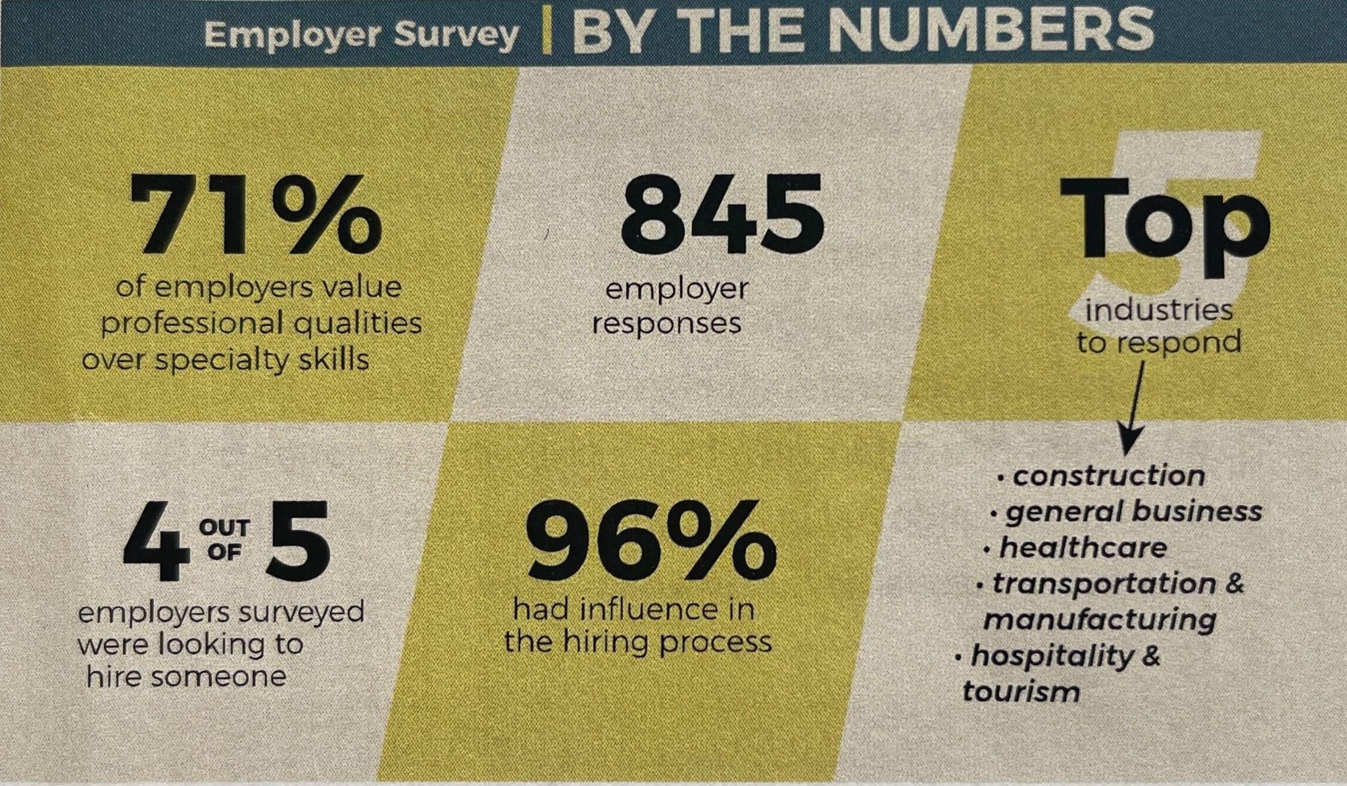

Idaho by the Numbers: Idaho Workforce Development Council
On Thursday morning, legislators in the Farm, Ranch, and Timber Caucus met with Wendi Secrist, the Executive Director of the Idaho Workforce Development Council to discuss employment and education opportunities in Idaho. The Workforce Development Council is an independent office under the Governor charged with preparing Idahoans for careers that meet Idaho employers’ needs.

Bolstered by $1M in CARES Act funds, the Council started a new project, Idaho Launch, in November 2020. As part of that project, they conducted a survey of Idaho employers. They learned that 80% of employers were hiring, in industries ranging from construction to healthcare to transportation. The Council operates in partnership with the private sector, Idaho Business for Education, and the State Board of Education and has trained thousands of Idahoans. In conjunction with their partners, the Council launched a second website, Next Steps Idaho, a comprehensive set of resources and tools pertaining to education, training, and career exploration. The site is intended as a resource for anyone looking for information on careers, apprenticeships, technical education, or who don’t yet know what they want to do. The entire site and all of its self-discovery tools are 100% free and open to the public.

Bill Tracker (will be updated Friday before distribution)
S1311

S1312 This proposed legislation would amend existing law to revise provisions regarding the careless exposure of barbed wire and to revise penalties. Printed and referred to Agricultural Affairs.

S1319 This bill amends contracts regarding school transportation services. Reported out of Committee with Do Pass Recommendation. Read a second and third time.

S1280 This bill would define dyslexia in Idaho code, and recognize the unique influence and challenges students with characteristics of dyslexia face in developing their reading and literacy skills. The bill would require that school districts and charter schools assess students in kindergarten through fifth grade for characteristics of dyslexia so plans for specific interventions can be identified and offered. Passed the Senate 33-0-2 and referred to House Education.

S1254 Amends, repeals, and adds to existing law to remove certain provisions regarding air quality related to motor vehicles and to provide revised provisions regarding air quality programs. Reported out without recommendation as amended. Amendments ordered printed, referred for engrossment.

H461 Amends existing law to revise eligibility requirements for the Armed Forces and Public Safety Officer Scholarship. Passed the House 67-0-3, and filed for a third Senate reading.

S1291 Amends existing law to provide alternative methods of obtaining certain certifications. Reported out without recommendation as amended. Amendments ordered printed, referred for engrossment.

S1228 Repeals existing law relating to enclosures of reservoirs and dumps. Passed the Senate 35-0 and referred to House Resources and Conservation

HCR 29 States findings of the Legislature and encourages certain officers, agencies, and employees of the State to become informed about the impacts of traumatic childhood experiences and to implement interventions and practices to develop resilience in children and adults who have suffered from traumatic childhood experiences. Ordered Transmitted to Secretary of State

S1287 Adds to existing law to establish the rural nursing loan repayment program. Failed 14-17-4

H 444 Amends 2021 session law to extend a sunset date to July 1, 2023. Filed for a second reading with Do Pass recommendation. Sent to the Governor's desk.

H 461 This bill aims to update Idaho code 33-4302 so that the child or spouse of a military member who has fallen in combat is eligible for this scholarship, seeing that they meet other prerequisites laid out in the bill. Passed the House 67-0 and filed for a third Senate reading.

H 506 This bill would amend Section 33-4302(7) of Idaho Code to allow the Idaho Division of Veterans Services to determine disability for members of the Armed Forces, instead of the United States Social Security Administration. Passed the House 66-0 and filed for a third Senate reading.

HB 436 Income tax rebate; reduces independent and corporate income tax rate. House passed 57-13; Passed Senate 27-7-1. Signed by the Governor on February 4, 2022.

HB 441 This bill offers absentee ballot assistance for those in nursing care facilities by designating three authorized sources of voter assistance. Referred to House State Affairs.

HB 443: This proposed legislation will create a dedicated fund to bring school district employees’ healthcare coverage up to the same standard as that of state employees. The bill passed the House 55-14, passed the Senate 32-3 and has been signed by the Governor.

HB 450 This proposed legislation will provide employers with unemployment insurance tax rate stability and consistency by extending the 2021 unemployment insurance base tax rate over a period of two years. This will result in a tax savings of $64 million for Idaho businesses over the next two years. Reported Signed by Governor on February 18, 2022.

SB 1226 This legislation declares that Idaho students can be designated as self-directed learners if they meet the criteria laid out in the bill. Introduced, printed and referred to Senate Education.

SB 1239 This bill would require the legislative session to end on or before the last Friday in March each year unless two-thirds of each house votes to go longer. A similar bill was introduced last year, but died in the house. Introduced, printed and referred to Senate State Affairs.

SB 1241 This bill makes a change to Idaho Code by increasing the maximum value of a home that qualifies for the property tax reduction program (aka Circuit Breaker) to assist more low-income applicants to remain in their homes. Reported out of Senate Local Government & Taxation with a do-pass recommendation. On Senate Second Reading Calendar.

SB 1249 This bill corrects an error in last year's H 389 so that expiring Urban Renewal Districts come into local property tax budgets at eighty percent not subject to the eight percent cap. It also closes an unintended loophole regarding the use of foregone balances in property tax budgets. Reported out of Senate Local Government & Taxation with a do-pass recommendation. Passed the Senate 34-0-1 and referred to House Revenue and Taxation

SB 1255 This bill creates The Empowering Parents Grant Program which will provide funding to parents to help meet their child’s educational needs and to address any learning loss with grants of $1,000 per student or a maximum of $3,000 per family for public and non-public students. Delivered to the Governor.

SB 1262 This legislation enhances the protections for firearms, ammunition, and components during a declared disaster emergency. Delivered to the Governor.

You are receiving this email because you have indicated an interest in legislative activities by emailing your Legislator or signing up for this newsletter. If you would prefer not to receive it in the future, please click the unsubscribe link in the blue box below to be immediately unsubscribed.

